**Software Requirements Specification**

**Version 1.2**

3rd March, 2025

Alumni Connect Portal

|  |  |
| --- | --- |
| Jasmeen Kaur | 202311037 |
| Manini Rajbhar | 202311049 |
| Namra Koyani | 202311057 |
| Pratham Popatiya | 202311065 |
| Saransh Naik | 202311077 |

Submitted in partial fulfilment for the requirements of

CS266 Software Engineering

**SRS Versions**

|  |  |  |
| --- | --- | --- |
| **Version** | **Date** | **Description** |
| v1.0 | 18/01/2025 | Initial SRS document created using example template |
| v1.1 | 10/02/2025 | Suggestions and changes incorporated in SRS |
| v1.2 | 03/03/2025 | Formatting made more uniform |

**Table of Contents**

# Introduction

* 1. Purpose
  2. Definitions, acronyms, and abbreviations
  3. Intended Audience / Stakeholders
  4. Project Scope
  5. References

# Overall description

* 1. System Environment
  2. Functional Requirements
  3. Non-Functional Requirements
  4. Constraints
  5. Assumptions and dependencies

# External Interface requirements

* 1. User interfaces
  2. Hardware interfaces
  3. Software interface
  4. Communications interfaces

# Other Nonfunctional Requirements

* 1. Safety Requirements
  2. Security Requirements
  3. Performance Requirements

**List of Figures**

Figure 1. System Environment

Figure 2. Use Case Diagram

Figure 3. Admin Use Case Diagram

Figure 4. Alumni Use Case Diagram

Figure 5. Current Student Use Case Diagram

Figure 6. Faculty Use Case Diagram

## Introduction

This section gives a scope description and overview of everything included in this SRS document. Also, the purpose for this document is described and a list of abbreviations and definitions is provided.

## Purpose

The purpose of this document is to give a detailed description of the requirements for the “Alumni Connect Portal” software. It will illustrate the purpose and complete declaration for the development of system. It will also explain system constraints and interface. Once finalized, this document will state what must be accomplished for the system to be considered finished.

## Definitions, acronyms, and abbreviations

|  |  |
| --- | --- |
| **Term** | **Definition** |
| User (Alumni, Current Student, Faculty, System) | Someone / something who / which interacts with the web-application. |
| Admin/Administrator | System administrator who is given specific permission for managing and controlling the system |
| Web-Portal | A web-platform that serves as a centralized interface where alumni, students, and administrators can interact, access resources, share opportunities, and stay connected with their alma mater. |
| Stakeholders | Individuals or groups who have an interest in the project's outcome, including users, developers, clients, and other parties affected by the system. Their needs and expectations shape the requirements and scope of the project. |
| System Environment | External factors and conditions that the system interacts with. |
| Web-based | Systems that are accessed and operated through a web browser over the internet, without requiring installation on a user's device. |
| Interface | It is a shared boundary or point of interaction between two or more systems enabling communication and data exchange between them. |

## 1.3 Intended Audience / Stakeholders

There are four types of users who interact with the **Alumni Connect Portal**, each with distinct roles and requirements.

1. **Alumni:** Alumni are one of the primary users of the portal. They can create and update their profiles, showcasing their personal and professional information. They use the platform to network with fellow alumni, and engage with events. Their main interaction with the portal is to maintain their profiles and stay connected with their alma mater.
2. **Students:** Current students use the portal to find career guidance, connect with alumni, and participate in events. Their primary goal is to leverage the platform to enhance their academic and career prospects by networking with alumni and staying updated on opportunities.
3. **Administrators:** Administrators manage the overall functioning of the Alumni Connect Portal. They are responsible for overseeing user accounts, maintaining the accuracy of the data, and ensuring smooth platform operations. Administrators can monitor activities, publish announcements, organize events, and manage both alumni and student profiles.
4. **Faculty:** Faculty members interact with the portal to facilitate connections between students and alumni. They may participate in academic collaborations, share opportunities for students, or invite alumni for guest lectures or industry insights. Faculty can also access alumni profiles and event information, contributing to the development of academic programs and student engagement.

## Product Scope

The Alumni Connect Portal is web-designed to bring alumni, students, faculty, and the institution closer together in a meaningful and engaging way. It provides a platform where alumni can stay connected with their alma mater, share valuable opportunities, contact faculties, and contribute to the institution’s growth. For students, it offers a chance to learn from alumni, gain career guidance, and explore opportunities in their field. Faculty and administrators can use the portal to manage alumni interactions and organize events.

## References

[1] IEEE Software Engineering Standards Committee, “IEEE Std 830 -1998, IEEE Recommended Practice for Software Requirements Specifications”, October 20, 1998

# Overall Description

This section will give an overview of the whole web-application. The Alumni connect portal will be explained in its context to show how it interacts with other systems and introduce the basic functionality of it. It will also describe what type of stakeholders that will use the portal and what functionality is available for each type. At last, the constraints and assumptions for the system will be presented.

## System Environment

***Fig 1. System Environment***

The Alumni Connect Portal has four active actors and one cooperating system.

The Alumni, Current Students, and Faculty access the Alumni Connect Portal through the Internet. Any communication between Alumni, Faculty, and Students is facilitated through the portal's messaging system. The admin accesses the entire system directly to manage users and events. There is an integration with a database for user verification and data retrieval.

## Functional Requirements

This section outlines the use cases for each of the active actors in the Alumni Connect Portal. Each actor—alumni, current students, faculty, and admin—has distinct use cases based on their role and interactions with the system.

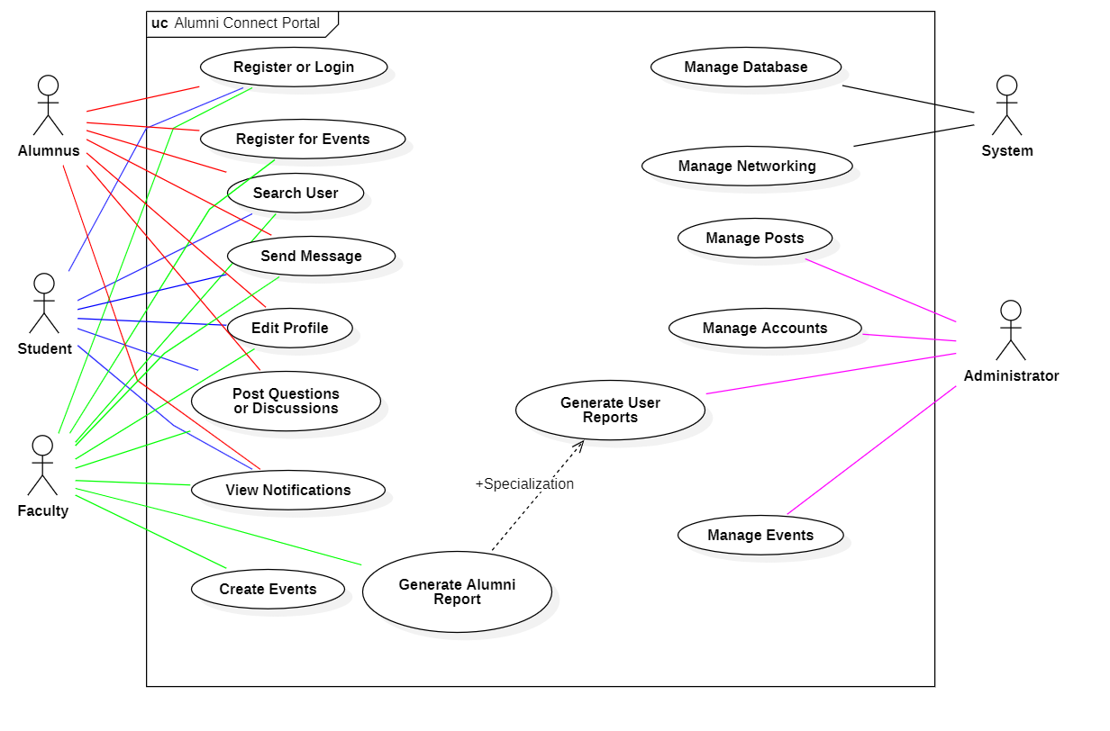The following is the overall use case diagram of the system:

***Fig 2. Use Case Diagram***

* + 1. 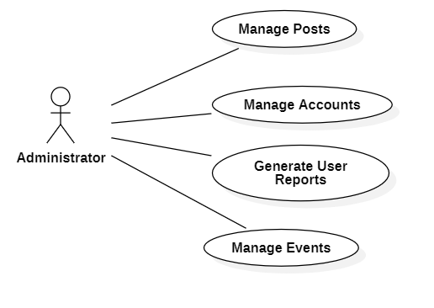**Admin Use Case Diagram:**

***Fig 3. Admin Use Case***

**Brief Description:** The admin manages posts by checking them for posting guidelines.

Admin also manages users by approving or rejecting registration requests, and updating, deactivating user accounts and monitoring the contents of the portal for safety.

The admin can generate user reports to get the user’s entire history of using the website.

The admin can create new events or delete events created by any faculty.

* + 1. 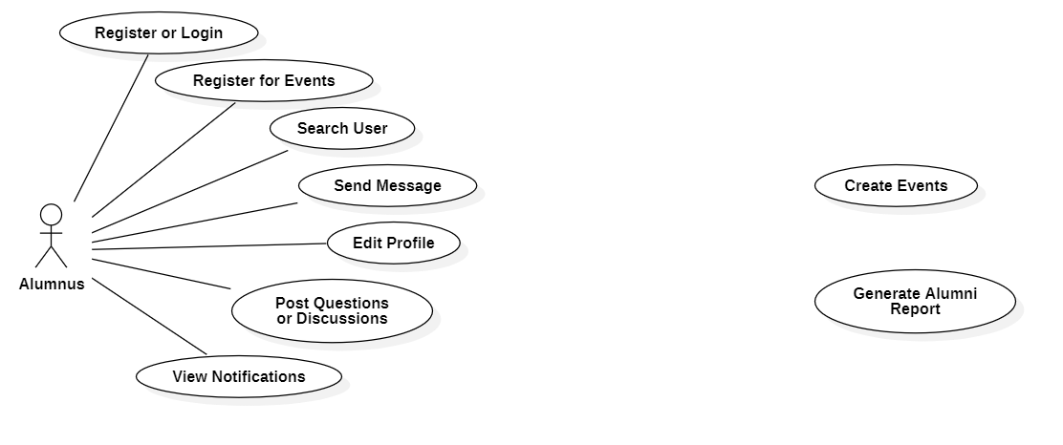**Alumni Use Case Diagram:**

***Fig 4. Alumni Use Case***

**Brief Description:** Alumni can Register or Login to gain access to the Alumni Connect Portal.

Alumni can register for events created by the faculty.

Alumni can search for other peers or faculties for networking.

Alumni can send direct messages to any other user.

Alumni can update their profile to ensure accurate details.

Alumni can post questions or start open discussions.

Alumni can view new or old notifications.

## Current Student Use Case Diagram:

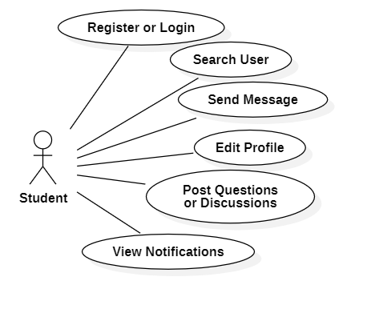

***Fig 5. Students Use Case***

**Brief Description:** Students can Register or Login to gain access to the Alumni Connect Portal.

Students can search for other users or faculties for networking.

Students can send direct messages to any other user.

Students can update their profile to ensure accurate details.

Students can post questions or start open discussions.

Students can view new or old notifications.

## Faculty Use Case Diagram:

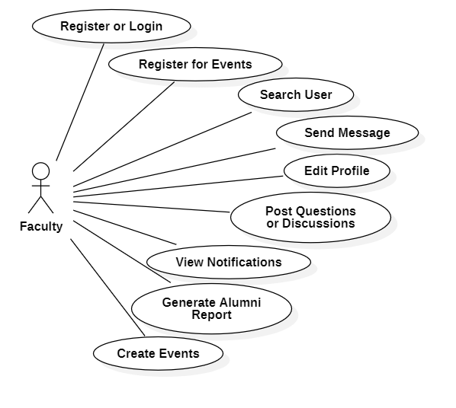

***Fig 6. Faculty Use Case***

**Brief Description:** Faculty can Register or Login to gain access to the Alumni Connect Portal.

Faculty can register for events created by the themselves or other faculty.

Faculty can search for other users.

Faculty can send direct messages to any other user.

Faculty can update their profile to ensure accurate details.

Faculty can post questions or start open discussions.

Faculty can view new or old notifications.

Faculty can generate a user report for any Alumnus.

Faculty can create and host events or webinars for other users.

## Non-Functional requirements

**2.3.1 Server Configuration**

The Alumni Connect Portal will be hosted on a server with high-speed internet capability to ensure seamless access for all users.

**2.3.2 Infrastructure Requirements**

The physical server to be used will be chosen by the institution. The speed of the user’s connection will depend on their individual hardware and internet service provider.

**2.3.3 Administrative Device**

The administrative tools will run on the administrators’ PCs and will connect to the database server.

**2.3.4 Operating System / Browser**

The portal will support access through modern devices running Linux, Windows, or macOS operating systems and will work across major web browsers such as Chrome, Firefox, and Edge.

## Constraints

## 2.4.1 Existing Database

The Alumni Connect Portal is constrained by the system’s dependency on the **institution’s existing databases**. Since the portal must integrate with these databases to fetch up-to-date information about alumni, events, and student records, any limitations or inconsistencies in the database structure can affect the portal's performance. If the database experiences high traffic or is unable to handle large data volumes, it may cause delays or errors when accessing the required information.

**2.4.2 Internet Speed**

The **Internet connection** also plays a critical role in the portal's functionality. Since the portal fetches data from the server in real-time, a stable and fast internet connection is necessary for smooth performance. Inconsistent or slow internet speeds can result in delayed loading times for profiles, events, and other data, negatively impacting user experience.

**2.4.3 Server Capacity**

The web portalis constrained by **server capacity**. As the portal grows and attracts more users, the server may experience higher traffic and struggle to manage the volume of data and requests. This could lead to slower response times, especially during peak usage times. Adequate server resources are required to ensure that users can access the portal seamlessly and without interruptions.

## Assumptions and dependencies

## 2.5.1 User Device Specifications

One assumption about the systemis that it will be accessed on devices with sufficient performance capabilities. If users access the portal on outdated devices or those running low on hardware resources, such as memory or processing power, certain features of the platform may not function as intended or may perform slowly.

**2.5.2 Existing Database Structured**

Another assumption is that the institutional database and related systems are consistently updated and structured in a standardized manner. If the database contains incomplete or inaccurate information, or if its format varies, the integration and data retrieval processes of the portal might not work as specified in this document. This could require additional adjustments to ensure compatibility.

**2.5.3 Sufficient Internet Speed**

The portal also assumes that users will have **reliable internet access**. If the internet connection is unstable or slow, users may experience delays in accessing profiles, events, or messaging features, which could hinder the intended user experience.

## External Interface Requirements

This section outlines the specific requirements of the Alumni Connect Portal, including the user interfaces, hardware, software, and communication interfaces essential for the system to function effectively.

## User Interface

The Alumni Connect Portal provides a user-friendly and intuitive interface designed to accommodate alumni, current students, faculty, and administrators. The web interface is accessible through **modern web browsers** such as Chrome, Firefox, Edge, and Safari. It includes features such as login and registration pages, personalized dashboards for managing profiles, event registrations, and messaging functionalities. These interfaces provide seamless navigation and support for push notifications to keep users updated about events, job opportunities, and new messages.

## Hardware Interface

The portal requires minimal client-side hardware, including desktops, laptops, or tablets with a reliable **internet connection**. These devices should run on **modern operating systems** such as Windows, Linux, or Macintosh, and have sufficient processing power to handle the functionalities of the portal. On the server side, the system should be hosted on robust and secure servers to manage **large-scale data processing** and user requests effectively.

Since it is a web-bases portal, the hardware requirements are minimal with only enough memory to run the user-desired web browser.

## Software Interface

The Alumni Connect Portal relies on a backend system built on a scalable and secure architecture. It includes user authentication modules, data storage systems, and real-time notification services. The software should integrate seamlessly with the existing institutional database to verify user identities and retrieve relevant information. Additionally, the portal supports email notifications and in-app messaging services to facilitate smooth communication between alumni, faculty, and students. The portal will use only web-based styling and processing, and hence no extra software is required.

**3.4 Communication Interface**

The portal facilitates effective communication through email notifications, which are triggered for events and incoming messages. An integrated messaging system within the portal allows alumni, faculty, and students to communicate directly. The system also supports real-time notifications for important updates, ensuring users are consistently informed about relevant activities and announcements.

## Other Nonfunctional Requirements

* 1. **Safety Requirements**

The Alumni Connect Portal must allow **admin access** to monitor user activity. If any suspicious activity is detected, the admin has the authority to ban the user to prevent harm or further issues on the platform.

## Security Requirements

The Alumni Connect Portal keeps users safe by using **secure logins** and only giving access based on their role. Personal data is protected with encryption, and users can control who sees their profile. Messages stay private, and all posts are checked to block harmful content. If users are inactive for a while, they are logged out to stay secure. Backups are made regularly to avoid losing data, and admins can manage activities like registrations and events without accessing private messages or sensitive info. These steps make the portal secure and trustworthy.

## Performance Requirements

The Alumni Connect Portal should load quickly, with pages opening in less than 3 seconds. It should handle at least **200 users** at once without slowing down, ensuring smooth interactions even during busy times. The system must also be able to store and manage a lot of data without crashing. Regular backups are needed to keep everything safe and running well.